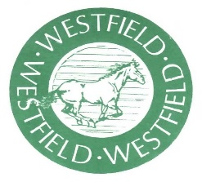**Westfield Park Recreation and Parkways District #12 26610 Eastvale Road, Palos Verdes Peninsula, CA 90274**

HOLD HARMLESS AND DEFEND STATEMENT

The person or group listed below is willing to assume liability, indemnify, defend and hold the Westfield Park Recreation and Parkways District #12 and their directors harmless from any loss, cost of expense whatsoever caused by negligent or wrongful acts or omissions of the below named person or group, agent, student or guest occurring while using the Westfield Riding Arena and surrounding area.

___________________________ _______________________________ _____________

Printed name Signature Date

Address: ______________________________________________________________________________

Cell Phone: __________________________________________